LEIGH ST PETER’S CE PRIMARY SCHOOL
LOVE RESPECT TRUST FRIENDSHIP RESPONSIBILITY PERSEVERANCE RESILIENCE

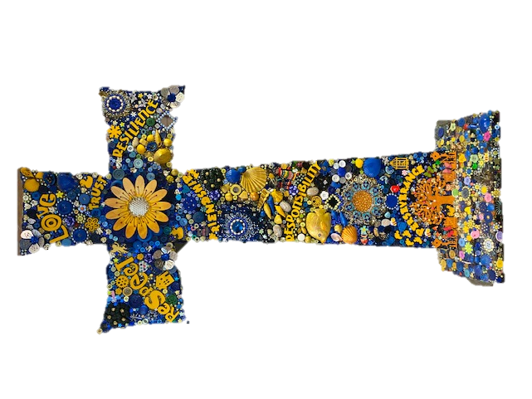
OCTOBER 2021 NEWSLETTER

INFORMATION:
We have had a good start to the year. Most children are settled and we are working with those that are struggling with the increase in workload and challenges in their new classes.
Last year we introduced Zones of Regulation. We have used the theme from the film Inside Out to help with this. These strategies help when your child is met with a challenge, either academically or socially. Currently we are spending time co-regulating many children, this is key to modelling what kind of behaviours are expected. If you want to learn more ask your children about it.

WHOLE SCHOOL IMPROVEMENT:
This year our key priorities in school are:
- Metacognition and self-regulation: This is about supporting children to be aware of what they are learning and controlling thought processes and feelings.
- Early Intervention: We are focusing on our youngest children’s speech and language needs.
- Parental Engagement: As we try to move back to some kind of normality we want to develop a range of activities to involve you in your child’s learning and look at new ways to support families.
- Social and Emotional Learning: We are introducing an assessment that looks more closely at children’s attitudes to learning. We are also further developing the Zones of Regulation to support children to regulate after a crisis point using an app called PIL (Post Incident Learning).
As always, we will also have subject specific actions focused on improving your children’s outcomes.

NATIONAL DAY OF LANGUAGES:
At the end of September it was National Day of Languages so your children were all learning basic greeting in the language chosen by the teacher. We have been very lucky that some of our children’s first language is not English so they helped teach us something new. Please see below the languages taught.
EYFS: Makaton
Year 1: Spanish
Year 2: Gaelic
Year 3: Polish
Year 4: Thai
Year 5: Chinese
Year 6: Shona and Ndebele

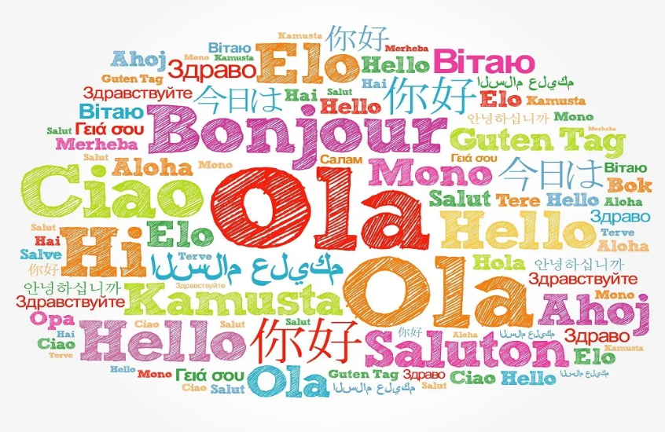
DATES FOR YOUR DIARY:

Friday 15th October
Show Racism the Red Card

Friday 15th October
Half term holiday

Monday 1st November
School returns

Tuesday 21st December
Christmas Holiday begins

LOVE:
Our Christian value this half term is LOVE.
This bible quote from Colossians 3:14: “Above all be loving. Love ties everything together perfectly”.

Together with God we challenge minds, recognise talents and build dreams.

BLACK HISTORY MONTH:
October is Black History Month. The last few weeks your children have been learning about significant people and events that have changed or affected others. Talk to your child about their learning.
EYFS: Theme The Same but Different.
Year 1: Have been learning about how people feel when treated differently because of the colour of their skin. Examples of people and events are Rosa Parks and The Bristol Bus Boycott.
Year 2: Have been looking at how racial abuse affects sports personalities and the positive impact they have had on our society eg Marcus Rashford (Food Parcels), Walter Tull and Jack Leslie (Black Professional Footballers).
Year 3: The Windrush Generations: how important they were to helping build the UK after the war. This follows on from their work on WW2
Year 4: Cheddar Man and Beachy Head Women. They will learn about skeleton and remains found in southern areas of England. This links to Excavation in their Egyptian topic.
Year 5 and Year 6: Are looking at people involved in the law and those representing vulnerable adults with protected characteristic.

Although we use October to promote diversity, it is also develop throughout the curriculum during the rest of the school year.

SCHOOL DIARY DATES (AUTUMN 2)
Wednesday 3rd November | Virtual Open Evening: 5.00pm Please let anyone know whose child is due to start Nursery or school in September 2022. Click on the QR code to register. We also have places in Nursery for this year please speak to Mrs Scully for more details.
Friday 19th November | Children in Need: Non Uniform Day £1 donation
Week Beg: Monday 15th November | Anti-bullying Week 2021: One Kind Word
Friday 26th November | Non-Uniform Day: KS1 children please bring in a bag of Haribo sweets to go on the tombola stall for the Christmas fayre; KS2 please bring £1 donation towards the church funds.  Church Christmas Fair - 3.30pm (Please note the change of day and time)
Friday 3rd December | Inclusion Day: Today is International Day of Disabilities. This is a day the UN support to spread the word on disability issues and support for dignity, rights and well-being. As we have a high number of children with SEND (special educational needs) we will be working with children to develop their understanding of differences, compassion and acceptance.
Wednesday 8th December | Flu Immunisation: Please complete the online form before 24th November https://www.nhsimms.uk/FLU/information?Id=135841&Type=FLU
Friday 10th December | Christmas Jumper Day - £1 donation  School Christmas Meal.
Monday 13th December | Year 3,4,5 and 6 I-Sing Pop Christmas Concert:  2.00pm and 6.00pm concerts. This concert will be held in the church. Letters will go out with information on how to buy tickets, CD’s of the concert and I-SING Pop T-shirts. All Y3-6 children are expected to attend both concerts.
Christmas nativities dates will be decided at the beginning of next half term.
Tuesday 21st December | LAST DAY OF TERM
Wednesday 5th January | TERM STARTS
WEBSITE: https://leighsaintpeters.wigan.sch.uk/ TWITTER: @leighstpeters FACEBOOK: @leighstpeters

Together with God we challenge minds, recognise talents and build dreams.

